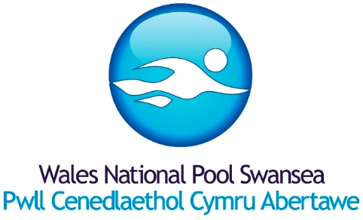
COVID PARTICIPATION STATEMENT

As Wales moves into Alert Level O, it is essential that customers are aware of the WNPS requirements and whether it is suitable for you to use the facility.

To ensure a safe environment for staff and customers:-

WNPS will:-

- Ensure the ventilation systems are set as per CIBSE guidance.
- Request, as per Welsh Government guidance for indoor facilities, all customers wear face masks, unless swimming or exempt.
- Encourage customers to use the WNPS Track and Trace QR code displayed at the main entrance.
- Provide sanitiser stations at key locations.
- Encourage all customers and staff to be mindful of the personal space of others and maintain social distancing.
- Continue enhanced cleaning regimes.
- Provide sanitizing wipes for customers to clean cubicles & lockers before/after use.
- Encourage staff to take lateral flow tests (minimum 2 per week).

We are asking our customers to:-

- Wear a face mask unless you are swimming or exempt.
- Register your visit via the Track and Trace QR code displayed at the main entrance.
- Sanitise your hands upon entering WNPS and when moving through the facility.
- Arrive beach ready to minimise time spent in the facility.
- Be mindful of the personal space of others and maintain social distancing.
- Clean your cubicle & locker before/after use.

