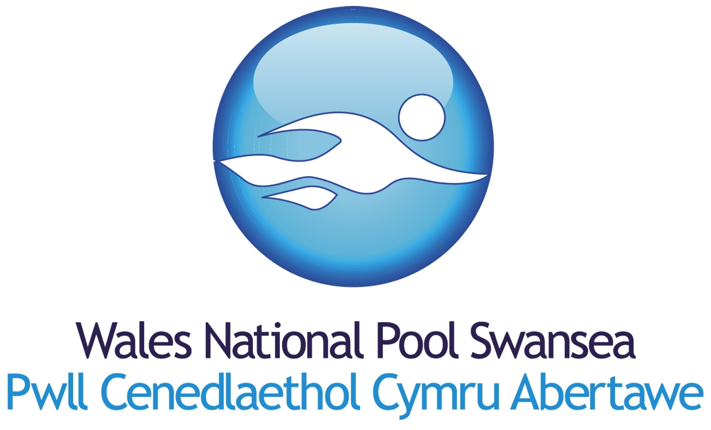
J O B D E S C R I P T I O N

TITLE: |  | Sports Assistant/Lifeguard
SALARY
  £19,293
RESPONSIBLE TO: |  | Duty Manager

MAIN PURPOSE OF JOB
To assist in the efficient, effective and economic delivery of services in order to fulfil the requirements of Wales National Pool Swansea (WNPS) and Swansea Bay Sports Park (SBSP). Under direction of Managers, to ensure the sports facilities, programmes, associated areas and service delivery are of the highest standard during all hours.

Sports Assistants will be required to work on a shift rota that will include regular evening, weekend and Bank Holiday work.

MAIN DUTIES

- To be responsible, under guidance of Duty Managers for the effective operation of the facility in terms of lifeguarding, security, cleanliness, safety of customers and emergency procedures.

- To maintain a high level of personal fitness and health in order to fulfil the extremely physical requirements of this role.

- To be conversant with the Wales National Pool Swansea and Swansea Bay Sports Park (SBSP) Customer Care Policy and to integrate into all dealings with WNPS and SBSP visitors and staff.

- To assist in the efficient implementation of the sports programme ensuring the needs of the various user groups are met in the most effective and economical manner possible.

- To be responsible for spot cleaning of all sports facilities and associated areas as directed by Managers, to include the cleaning of swimming pool, changing areas, corridors, catering, and meeting and reception areas.

- To assist in providing prompt and accurate information for existing customers and potential customers of the facility.

- To check all membership cards/tickets and to challenge unauthorised entrance to prevent inappropriate use of the facility.

- To ensure that equipment in the store cupboards are kept neat and tidy and to report/log any losses or damage.

- To deal with lost property items and to record and store items in an appropriate manner in conjunction with a Manager.

- To carry out and assist with pool assessments where requested, in accordance with qualifications held and if so directed by the Managers.

- To assist in testing the quality of the pool water if so directed by Managers.

- To be responsible for maintaining personal equipment and uniform.

- To undertake personal Health and Safety responsibilities within the HASAWA Act 1974.

- To adhere to Normal Operating Procedures (NOPs) and Emergency Action Plans (EAPs).

- To ensure that all activities are operated in accordance with Equal Opportunities’ Legislation and the Wales National Pool Swansea and Swansea Bay Sports Park (SBSP) Equal Opportunities Policy.

- To be a strong team member within the staffing structure, providing back up and support and where necessary carrying out duties of another member of the sports team in the event of absence, holiday or illness.

- To carry out other duties as reasonably directed by Managers to assist in supporting the Wales National Pool team.

Disclosure and Barring Service (DBS) –

This post due to its nature, duties and responsibilities, will be subject to a check by the Disclosure and Barring Service. The level of check will be an enhanced check. Should you have any queries in relation to this check by the DBS, please contact me.

You are also required to inform the Wales National Pool Swansea immediately if you are convicted of a criminal offence, after a DBS Application has been processed for you.
www.disclosure.gov.uk.

Review date/right to vary:

This job description is as currently applies and will be reviewed regularly as part of a Personal Development Plan, and may be subject to other variance. You may be required to undertake other tasks that can be reasonably assigned to you which are within your capacity and grade.

NAME:.............................................................

SIGNATURE:............................................................

Date prepared/issued:

P E R SO N S P E C I F I C A T I O N

POST TITLE: | Sports Assistant / Lifeguard
EDUCATIONAL QUALIFICATIONS | Literate and Numerate.  Customer Care qualification would be desirable.
TECHNICAL COMPETENCE | RLSS National Pool Lifeguard or STA Pool NARS.  Capable of passing a Wales National Pool Swansea pool test.
EXPERIENCE | Working with members of the public in a customer orientated environment.  Health & Safety.
SKILLS & ABILITIES | Essential  Competent swimmer  Desirable  Commitment to personal health/fitness  Ability to work as part of the team.  Honesty and Integrity  Friendly and approachable  Communication and interpersonal skills.  Ability to communicate in Welsh would be desirable.  Flexibility in approach.  Problem solving.  Respond positively to change.  Good attention to detail.  Ability to work under pressure.  Punctuality.  Sense of pride  Strong work ethic  Have a high level of pride in personal appearance.  A commitment to sport and recreation.
COMMITMENT  TO EQUAL OPPORTUNITIES | Candidates should have knowledge of the Wales National Pool’s and Swansea Bay Sports Park Equal Opportunities Policy and an appreciation of how these Policies affects procedures and practices.
SPECIAL REQUIREMENTS | Candidates may need to be prepared to work “out of hours”.  Special consideration may be given to strong candidates interested in the position but not holding an RLSS qualification. However such candidates must have a high level of fitness and be a strong swimmer in order to undertake intensive training. Only candidates that pass training will be appointed to a position.  This post requires an enhanced level of disclosure. The successful candidate will need to complete a DBS application for this level of disclosure.

DISCLOSURE AND BARRING SERVICE (DBS)
DISCLOSURE CHECKS

The Disclosure and Barring Service (DBS), an Executive Agency of the Home Office, provides wider access to criminal record information through its Disclosure service.

This service enables organisations in the public, private and voluntary sectors to make safer recruitment decisions by identifying candidates who may be unsuitable for certain work, especially that involve children or vulnerable adults. The DBS was established under Part V of the Police Act 1997 and was launched in March 2002.

The DBS can issue 5 levels of Disclosure Certificates, depending on the position applied for, namely Standard, Enhanced, Enhanced with ISA check (children), Enhanced with ISA check (adults) and Enhanced with ISA check (children and adults)

Prospective applicants should be aware that before any offer of appointment is confirmed the successful candidate will be required to complete an application for the appropriate level of disclosure; the Wales National Pool Swansea will provide the relevant DBS Application Forms. Proof of the successful candidate’s identity will also be required in the form of the following: Passport, Driving Licence, Birth Certificate and Utility Bills.

Wales National Pool Swansea actively promotes equality of opportunity for all existing employees and prospective applicants. Candidates are selected on the basis of skill, qualifications and experience, and their match against the Person Specification. A criminal record will not necessarily bar applicants from working with the Wales National Pool Swansea. It will depend on the nature of the position and the circumstances and background of the offence.

Wales National Pool Swansea has a written Policy on the Recruitment of Ex-offenders, which complies with the DBS Code of Practice, and undertakes to treat all applicants fairly. The DBS’s Code of Practice; the Wales National Pool Swansea Policy on the Security of Confidential Disclosure information and; information on the Rehabilitation of Offenders Act 1974 is available from the Sports Manager for Human Resources.
Further information about the DBS can also be found at www.homeoffice.gov.uk/agencies-public-bodies/dbs/

